Problem 1:

1. On the first breakpoint, number1 and number2 are in memory with their respective values. In the Registers tab, EAX has a default value and number1’s value, FFFFFF97, is showcased.

Number1’s Memory



Number2’s Memory



Sum’s Memory



Registers



1. On the second breakpoint, number1 had been moved to the EAX register. Now number2 is being showcased to show that is about to be added to the EAX register.

Number1’s Memory



Number2’s Memory



Sum’s Memory



Registers



1. On the third breakpoint, number2 had been successfully added to the EAX register giving it the value, “FFFFFFCB”, which is 53, the sum of the two numbers. Now we are shown the current value of the sum variable, 0, so it will be stored into memory.

Number1’s Memory



Number2’s Memory



Sum’s Memory



Registers



1. On the fourth breakpoint, sum has been stored into memory. Also, sum’s hexadecimal representation has been added to the ends both number1 and number2 in memory as shown here.

Number1’s Memory



Number2’s Memory



Sum’s Memory



Registers



1. On the fifth breakpoint, the EAX register’s value had been set to 0, and after this execution, the program will end.

Number1’s Memory



Number2’s Memory



Sum’s Memory



Registers



Problem 2:

1. On the first breakpoint, the three prompts, resultLbl, and sum are placed in memory as their default values as seen below. Prompt1 is about to set by the next breakpoint

Prompt1

Prompt2

Prompt3

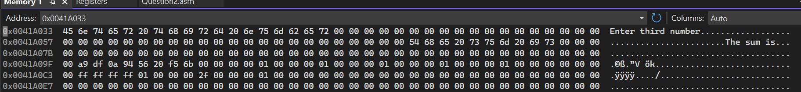

ResultLbl



Sum

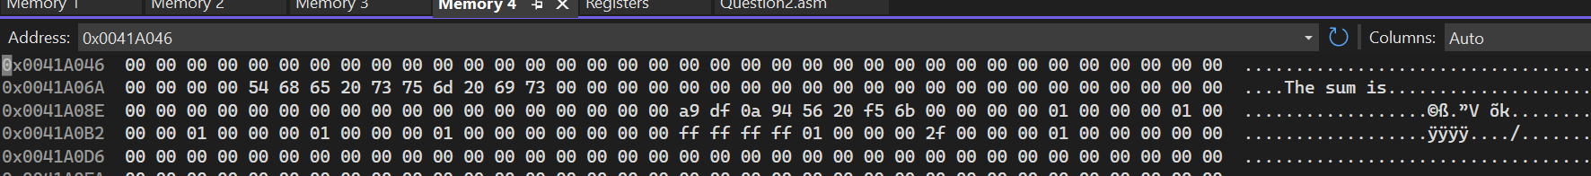

1. On the second breakpoint, the first number is prompted into prompt1 then is placed into string. 56 is the number given to prompt1 that will turn into number1 later.

String



1. On the third breakpoint, the string value, 56, had been placed in the EAX register and the value is ready to be moved into number1’s memory.

Registers



1. On the fourth breakpoint, 56, in the EAX register, had been placed into number1’s memory. Prompt2 is ready to be prompted.

Number1



1. On the fifth breakpoint, the second number is prompted into prompt2 then is placed into string. 89 is the number given to prompt2 that will turn into number2 later.

Prompt2



1. On the sixth breakpoint, the string value, 89, had been placed in the EAX register and the value is ready to be moved into number2’s memory.

Registers



String



1. On the seventh breakpoint, 89, in the EAX register, had been placed into number2’s memory. Prompt3 is ready to be prompted.

Number2



1. On the eighth breakpoint, the third number is prompted into prompt3 then is placed into string. 672 is the number given to prompt3 that will turn into number2 later.

Prompt3



String



1. On the ninth breakpoint, the string value, 672, had been placed in the EAX register and the value is ready to be moved into number3’s memory.

Registers



1. On the tenth breakpoint, 672, in the EAX register, had been placed into number3’s memory. Now number1 is ready to be moved into the EAX register.

Number3



Registers



1. On the eleventh breakpoint, number1’s value had been moved into the EAX register, and number2 is ready to be added to the register next.

Registers



1. On the twelfth breakpoint, number2’s value had been added in the EAX register, and number3 is ready to be added to the register next.

Registers



1. On the thirteenth breakpoint, number3’s value had been added to the EAX register.

Registers



1. On the fourteenth breakpoint, EAX’s value had been converted to ASCII characters and moved to sum.

Sum



1. On the fifteenth breakpoint, sum had been sent to resultLbl to be outputted to the screen.

ResultLbl



1. On the sixteenth breakpoint, 0 had been moved to the EAX register to reset it.

Registers

